**Experiment No. 06**

**1. Problem Statement:** A multiple-input multiple-output (MIMO) channel is equipped with n**T** transmitting antennas, n**R** receiving antennas, and n**I** interfering antennas

**(a) Investigate the effect of** transmitting antennas on the channel capacity of MIMO interference channel

**(b) Investigate the effect of** receiving antennas on the channel capacity of MIMO interference channel

**(c) Investigate the effect of** interfering antennas on the channel capacity of MIMO interference channel

**2. Derivation of the channel capacity** **for MIMO channel**

Let,

Received signal: $y=Hx+Gs+z=Hx+w$

Where,

𝒚 ∈ $C^{n_{R}×1}$ = Received Signal Vector

𝑯 ∈ $C^{n_{R}×n_{T}}$ = Channel Coefficient between the Transmitter and Receiver

𝑮 ∈ $C^{n_{R}×n_{i}}$ = Channel Coefficient between the Interferer and Receiver

𝒙 ∈ $C^{n_{R}×1}$ = Transmitted Signal Vector from the Transmitter

𝒔 ∈ $C^{n_{T}×1}$ =Transmitted Signal Vector from the Interferer

𝒛 ∈ $C^{n_{i}×1}$ = Noise Vector

w = Interference plus Noise Vector

**(i) Covariance of Received Signal:**

𝑹*y* = 𝐸[${yy}^{†}$] = 𝐸[(𝑯𝒙+𝒛) ${(Hx+z)}^{†}$]

= 𝐸[(𝑯𝒙+𝒛){${(Hx)}^{†}$ + ${(z)}^{†}$}]

= 𝐸[(𝑯𝒙+𝑧){${(x}^{†}H^{†}$ + $z^{†}$}]

= 𝐸[${(Hxx}^{†}H^{†}$ + ${Hxz}^{†}$ + ${zx}^{†}H^{†}$ + ${zz}^{†})$]

= 𝐸 ${[Hxx}^{†}H^{†}]$ + 𝐸 ${[Hxz}^{†}]$ + 𝐸 ${[zx}^{†}H^{†}]$ + 𝐸 ${[zz}^{†}]$

= 𝐸 ${[Hxx}^{†}H^{†}]$ + 𝐸 ${[zz}^{†}]$

= *H*𝐸 ${[xx}^{†}H^{†}]$ + 𝐸 ${[zz}^{†}]$

= *H* {$\frac{P_{T}}{n_{T}}I_{nT}$} $H^{†}$ + ${N_{0}I}_{nR}$ + *G* {$\frac{P_{l}}{n_{l}}I_{nl}$} $G^{†}$

= ${N_{0}[ I}_{nR}+MQM^{†} ]$

Where, $M=\left[ HG \right] ∈ C^{n_{R}(n_{T}+n_{l)}} and Q= \frac{P_{T}}{{N_{0}n}_{T}}I_{nR }⊕ \frac{P_{l}}{{N_{0}n}_{l}}I_{nl }$

**(ii) Covariance of Interference plus Noise signals**

𝑹*w* = 𝐸[${ww}^{†}$] = 𝐸[$(Gs+z){(Gs+z)}^{†}$]

= 𝐸[${Gss}^{†}G^{†}]$ + 𝐸[${zz}^{†}$]

= $G$ 𝐸[${ss}^{†}]G^{†}$ + 𝐸[${zz}^{†}$]

= ${N_{0}I}_{nR}$ + *G* {$\frac{P_{l}}{n_{l}}I_{nl}$} $G^{†}$

**(iii) Entropy of Received Signal**

𝑯(𝒚)= $\log_{2}det$ (𝜋𝑒𝑹*y*) = {𝜋𝑒 ${N_{0}[ I}_{nR}+MQM^{†} ]$}

**(iv) Entropy of interference plus noise signal**

𝑯(**w**)= $\log_{2}det$ (𝜋𝑒𝑹*w*) = {𝜋𝑒 ${N_{0}[ I}_{nR}+G \{\frac{P_{l}}{n_{l}}I_{nl}\}G^{†} ]$}

**v) Mutual information between x and y**

𝐼(𝒙;𝒚)=𝑯(𝒚)−𝑯(w) = $\log_{2}det$ (𝜋𝑒𝑹𝒚)− $\log_{2}det$ (𝜋𝑒𝑹w)

= $\log_{2}\frac{det⁡({ I}_{nR}+MQM^{†} )}{det⁡(I_{nR}+G \{\frac{P_{l}}{n_{l}}I_{nl}\}G^{†} )}$, which is the Mutual Information.

**(vii) Capacity at the Receiver:**

*C = ${}_{Q}^{max}{ I\left(x;y\right)= {}_{Q}^{max}{ \log_{2}\frac{det⁡({ I}_{nR}+MQM^{†} )}{det⁡(I_{nR}+G \{\frac{P_{l}}{n_{l}}I_{nl}\}G^{†} )}, }}$*

*= $\log_{2}[\frac{\det\left({ I}_{nR}+MQM^{†} \right)}{\det\left(I_{nR}+G \left\{\frac{P_{l}}{n_{l}}I_{nl}\right\}G^{†} \right)}]$* ,which is the channel capacity.

**3. Program for the channel capacity for MIMO interference channel**

* **MATLAB Code for plotting the capacity**

% Ergodic Capacity of Nr x Nt fading MIMO Channel with

% no channel knowledge at the transmitter.

clc

clear all;

%%%%%%%% Initialization %%%%%%%%

N=30000; % Number of Iterations for H

No=1; % Noise Variance

%%%%%%%% Number of antennas %%%%%%%%

nt=2; % Number of Transmit antennas

ni=2; % Number of interference antenna

nt=Nt+ni;

nr=6; % Number of Receive antennas

%%%%%%%% Correlation of antennas %%%%%%%%

rhot=0; % Correlation coefficient (Transmitter)

rhor=0; % Correlation coefficient (Receiver)

ExponencorrMrtx=ones(nt);%%%%%%%% Creation of SNR from 1 to L %%%%%%%%

for i=1:nt

for j=1:nt

if i==j

ExponencorrMrtx(i,j)=1;

end

if i>j

ExponencorrMrtx(i,j)=rhot^(i-j);

else

ExponencorrMrtx(i,j)=rhot^(j-i);

end

end

end

Rt=ExponencorrMrtx;

% generate an nxn exponential correlation matrix for Rr

ExponencorrMrtx=ones(nt);

for i=1:nr

for j=1:nr

if i==j

ExponencorrMrtx(i,j)=1;

end

if i>j

ExponencorrMrtx(i,j)=rhor^(i-j);

else

ExponencorrMrtx(i,j)=rhor^(j-i);

end

end

end

Rr=ExponencorrMrtx;

SNRdB=[0:1:35];

l=length (SNRdB);

SNR=zeros (1,l);

for i=1:l

SNR (i)=10^(0.1*SNRdB (i));

P(i)=SNR(i)*No;

end

Erg_Cap_unknown=zeros (1,l);

for i=1:l

C_unknown=zeros (1,N);

for j=1:N

H=CGM (nr,nt,Rr,Rt);

C_unknown (j)=log (det (eye (nr)+(SNR (i)/nt)*(H*H')));

end

Erg_Cap_unknown (i)=mean (C_unknown);

fprintf ('% e\t% e \n',SNRdB (i),Erg_Cap_unknown (i));

end

Erg_Cap_unknown=zeros (1,l);

for i=1:l

C_unknown=zeros (1,N);

for j=1:N

G=CGM (nr,nt,Rr,Rt);

C_unknown (j)=log (det (eye (nr)+(SNR (i)/nt)*(G*G')));

end

Erg_Cap_unknown (i)=mean (C_unknown);

fprintf ('% e\t% e \n',SNRdB (i),Erg_Cap_unknown (i));

end

plot (SNRdB,Erg_Cap_unknown)

xlabel ('SNR (dB)');

ylabel ('Ergodic capacity (bits/sec/Hz)');

title ('Ergodic capacity versus SNR');

grid on

hold on

**4. Numerical results of the MIMO channel**

**(a) Numerical data for measuring capacity at different SNR (dB)**

|  |  |  |  |
| --- | --- | --- | --- |
| **SNR (dB)** | **Capacity(bits/sec/Hz)** | **SNR (dB)** | **Capacity(bits/sec/Hz)** |
| 0 | 3.21022 | 16 | 14.7718 |
| 1 | 3.68846 | 17 | 15.6565 |
| 2 | 4.21794 | 18 | 16.5476 |
| 3 | 4.77797 | 19 | 17.4404 |
| 4 | 5.38851 | 20 | 18.3512 |
| 5 | 6.02162 | 21 | 19.2530 |
| 6 | 6.69693 | 22 | 20.1611 |
| 7 | 7.40800 | 23 | 21.0785 |
| 8 | 8.14525 | 24 | 21.9772 |
| 9 | 8.90590 | 25 | 22.8973 |
| 10 | 9.69533 | 26 | 23.8161 |
| 11 | 10.4940 | 27 | 24.7259 |
| 12 | 11.3237 | 28 | 25.6441 |
| 13 | 12.1671 | 29 | 26.5609 |
| 14 | 13.0249 | 30 | 27.4844 |
| 15 | 13.8944 |  |  |

**5. Effects of transmitting antennas**

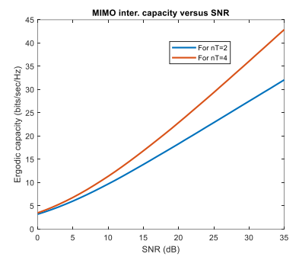

**Figure 6.1:** Increase in MIMO interference Capacity Vs SNR curve with transmitting antennas

**6. Effects of receiving antennas**

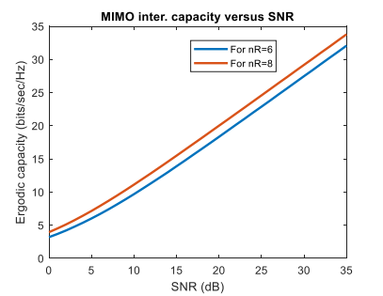

**Figure 6.2:** Increase in MIMO interference Capacity Vs SNR curve with receiving antennas

**7. Effects of interfering antennas**

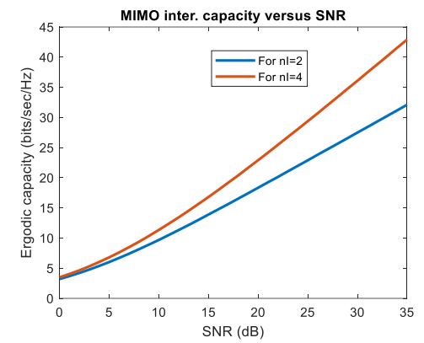

**Figure 6.3:** Increase in MIMO interference Capacity Vs SNR curve with interfering antennas

**8. Discussion and Conclusion**

**a) Discussion:** All of the figures depict the fluctuation in capacity in relation to SNR for various transmitting, receiving, and interfering antenna values. The channel capacity of a MIMO interference channel is determined by all factors, and we can improve the capacity by adding or decreasing the number of antennas. Interference is an adversary of every signal and should be avoided for optimal signal delivery.

**b) Conclusion:** From our investigation, we can draw the following conclusions:

* **The effect of interfering antenna on the capacity is more than another antenna.** An interfering antenna has a bigger impact on capacity than other antennas. When numerous antennas are functioning in a shared communication environment, the presence of interfering antennas can have a major impact on the channel's total capacity. Interfering antennas introduce new signal components into the mix, resulting in increased noise and probable signal deterioration.
* **Number of interfering antennas should be reduced to get high capacity of any channel.** Interference degrades signal quality and increases the risk of mistakes, lowering the possible data rate. As a result, the signal-to-interference-plus-noise ratio (SINR) improves, allowing for higher data rates and increased overall channel capacity.
* **Increased receiving antenna number gives us better SNR as well as the capacity.** Increasing the number of receiving antennas (using multiple-input, multiple-output, or MIMO techniques) can significantly improve both SNR and capacity. As the number of receiving antennas grows, the system can take advantage of spatial diversity and multipath propagation, resulting in higher SNR.

Finally, comprehending the statistical features of the MIMO channel as revealed by the ergodic capacity analyses is critical for building robust and efficient digital communication systems.